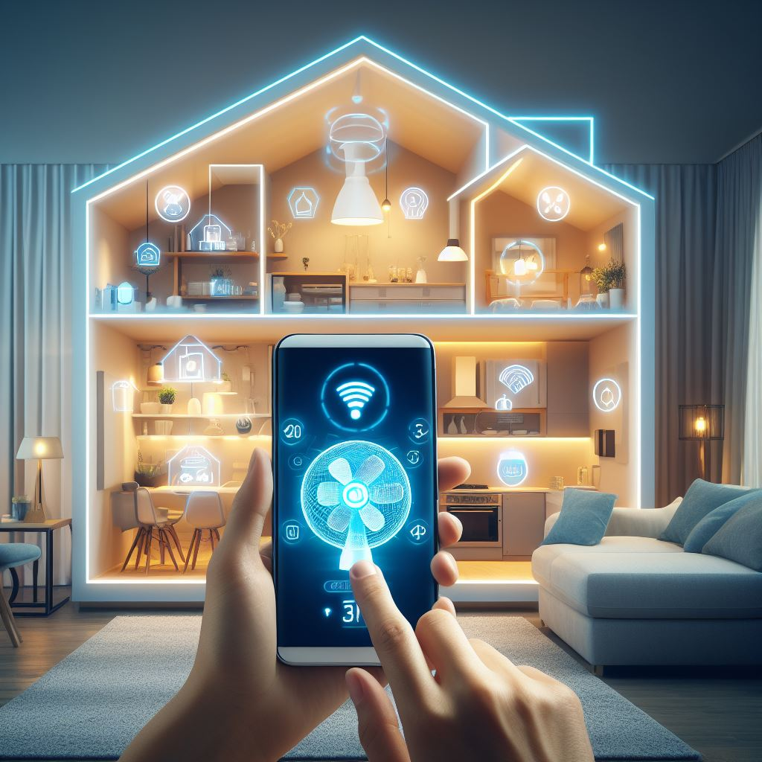

**HOME AUTOMATION SYSTEM**

**IOT INNOVATIONS**

Contents

**INTRODUCTION** 3

**Aim of the Innovation:** 4

**Novelty of the Innovation:** 5

**Process/Methodology of the Innovation:** 6

**System Planning and Design:** 6

**Integration of Hardware:** 7

**Calibration and testing:** 8

**Deployment and Installation:** 9

**Monitoring and Maintenance:** 10

**Limitation of project:** 10

**Avenues for Future Work:** 11

**Conclusion** 11

**References:** 13

**Table of Figures**

Figure 1 Home Automation with Blynk using NodeMCU ESP8266 4

Figure 2 Arduino Uno 5

Figure 3 Node-MCU ESP8266 5

Figure 4 dashboard for home automation 7

Figure 5 integration of arduino uno and esp module 7

Figure 6 integration of smd light | led | fans | temperature Sensor on Home Automation System 8

Figure 7 testing home automation working and analysing 9

Figure 8 code for Room 10

Figure 9 code for kitchen 10

Figure 10 code for temperature sensor and humidity 10

# **INTRODUCTION**

We explore the revolutionary field of home automation, powered by IoT innovation, in this academy study. Home automation represents a paradigm shift in how we interact with our living surroundings, not merely a modern convenience. Homes are currently savvier and more responsive than any other time thanks to the Web of Things (IoT) innovation. This paper examines the complex web of sensors, gadgets, and platforms that allow homeowners to regulate and keep an eye on a variety of characteristics of their living space, from fans and lights to the humidity and temperature in particular areas, like the kitchen. The progression of this innovation has not just expanded the level of accommodation and solace in our homes, yet it has additionally cleared the way for expanded energy proficiency and supportability.

Go along with us as we break down the hidden innovation, applications, advantages, and expected issues in the space of home robotization and IoT. Our exploration expects to give light on the present status of IoT-fuelled home mechanization, its effect on current residing, and possible future advances. This paper is a complete resource for anybody wishing to comprehend, investigate, or adopt IoT innovation in home automation."

# **Aim of the Innovation:**

The principal objective of this home computerization advancement controlled by the Web of Things (IoT) is to change the way in which we experience and associate with our residing spaces.Our goal is to give households unprecedented levels of control, convenience, and sustainability.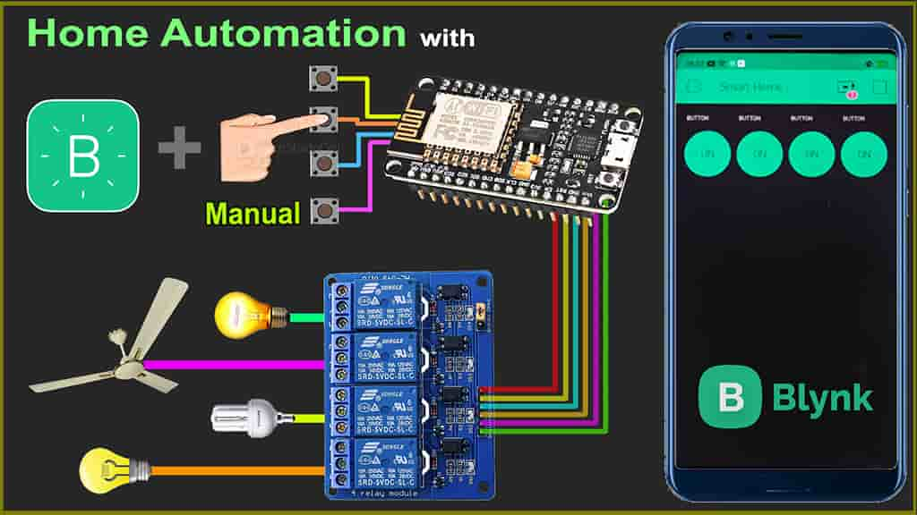

Figure 1 Home Automation with Blynk using NodeMCU ESP8266

**Objectives:**

1. **Control Simplicity:** Our underlying objective is to furnish mortgage holders with a straightforward method for dealing with their homes. We maintain that clients should have the option to control their lights, fans, and room settings effortlessly utilizing their cell phones and an easy to understand interface.

2. **Energy Efficiency:** Maximising energy efficiency is a significant goal. We intend to cut energy usage by optimising lighting, fans, and heating or cooling systems based on user preferences and occupancy by applying IoT technologies.

3. **Comfort and Personalization:** We strive to improve our consumers' comfort by allowing them to create customised environments. We want to simplify it for property holders to modify the feel and temperature of various rooms to their inclinations.

4. **Remote Accessibility**: We maintain that customers should have the option to get to their home's controls even while they are away. The objective is to furnish property holders with genuine serenity and comfort by permitting them to change or beware of their home from anyplace.

5. **Data-Driven Insights:** We intend to collect and analyse data on energy usage and consumer preferences using our IoT technology. Our goal is to offer homeowners with information that will allow them to make more educated decisions to improve efficiency and comfort.

Our goal is to revolutionise modern living through IoT-powered home automation, with goals focused on ease, energy efficiency, personalisation, remote access, and data-driven insights. This breakthrough envisions a future in which our homes actually adapt to our needs and preferences, making daily life more joyful and sustainable.

# **Novelty of the Innovation:**

The imaginative blend of Bylink, Arduino Uno, ESP8266, Wi-Fi sheets, transfers, temperature sensors, drove lights, SMD lights, and fans has introduced another period of home computerization with extraordinary elements and capacities.

Bylink's inclusion as a critical component demonstrates the originality of this concept. Bylink is a significant shrewd home stage noted for its not difficult to-utilize connection point and interoperability with a great many brilliant gadgets. This integration enables the smooth control and automation of a wide range of domestic equipment, enabling the home to become a holistic and interconnected ecosystem.

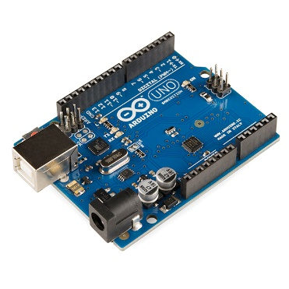 The utilization of an Arduino Uno as a focal handling unit adds a degree of flexibility and adaptability that recognizes this development. It acts as the system's brain, allowing homeowners to easily programme and automate their gadgets.

Figure 2 Arduino Uno

The incorporation of the ESP8266 as a Wi-Fi module is a crucial aspect of uniqueness. Its reconciliation guarantees that all connected gadgets can impart remotely, taking into account remote access and control through the web.

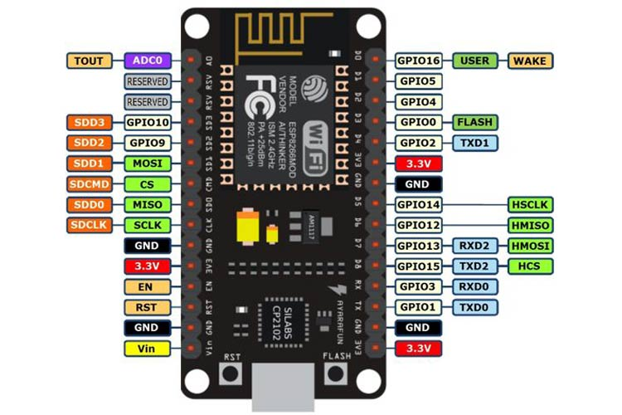The adoption of Wi-Fi boards increases the connectedness of the innovation. These boards provide real-time connection with mobile devices and the home's dashboard, allowing devices to be controlled and monitored from nearly anywhere. The incorporation of temperature sensors enables fine control of the room climate. This accuracy in environmental control characterises this innovation, offering an optimal, personalised environment. The use of both LED and SMD lights provides a choice of lighting alternatives, ranging from energy-efficient, long-lasting LED lights to the creative and colourful possibilities of SMD lighting, which adds both practicality and atmosphere to the invention. In and of itself, the ability to control fans as part of this integrated system is unusual. This feature improves user comfort and energy economy by adjusting fans based on occupancy and temperature.

Figure 3 Node-MCU ESP8266

This development is remarkable in that it adopts an exhaustive strategy to home mechanization, utilizing a very much picked mix of parts and innovation to offer smooth control, effective administration, and an exceptionally customized insight for property holders. Bylink, Arduino Uno, ESP8266, and the other components collaborate to build a smart home environment at the cutting edge of IoT innovation.

# **Process/Methodology of the Innovation:**

A preliminary assessment is performed during the initial step to discover the homeowner's individual automation needs. This evaluation informs the succeeding steps of system design. Furthermore, conversations are undertaken to establish the integration of important components such as Bylink, Arduino Uno, ESP8266, and other devices, ensuring that the proposed system matches with the homeowner's goals and requirements.

## **System Planning and Design:**

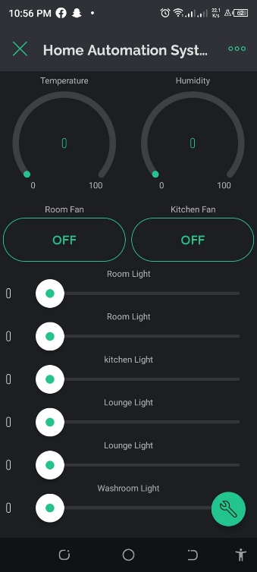The first step of the innovation process is concerned with meticulous planning and design. To understand the homeowner's individual demands, a detailed needs assessment is performed. This involves deciding on home automation features such as lighting, temperature control, and fan management. Following the evaluation, a careful selection of components and devices is made, with Bylink serving as the central platform, Arduino Uno for control, ESP8266 for wireless communication, Wi-Fi boards for networking, relays for device control, temperature sensors for environmental data, LED lights for efficient illumination, SMD lights for creative lighting, and fans for climate control.

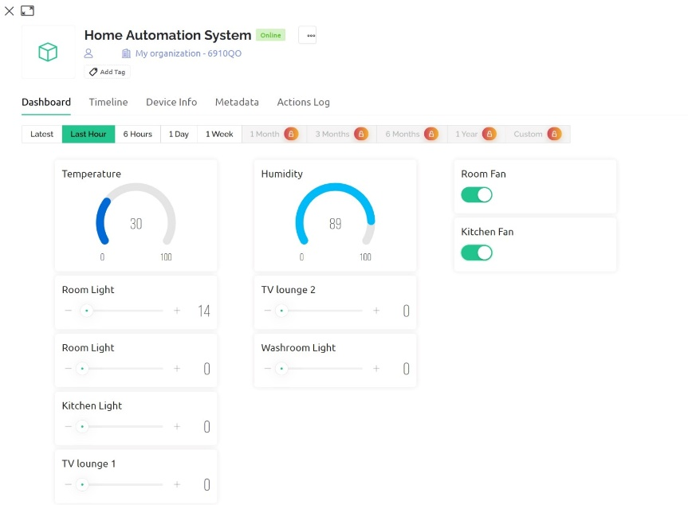

Figure 4 dashboard for home automation

## **Integration of Hardware:**

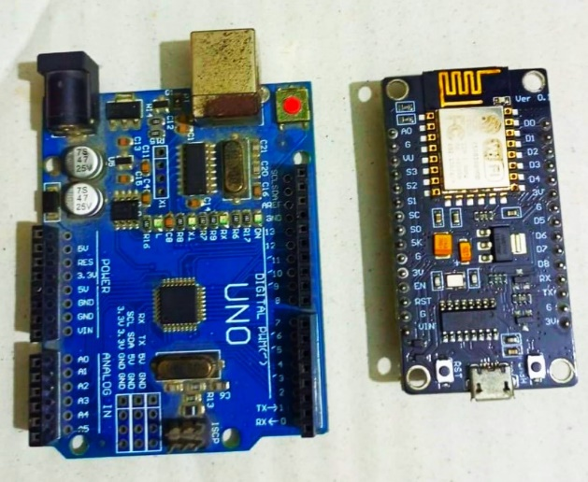

Figure 5 integration of arduino uno and esp module

The hardware integration phase includes the physical installation of the chosen components. Bylink is introduced and designed to act as the essential gadget the board center point, guaranteeing similarity with many brilliant gadgets and giving an easy to understand interface. The Arduino Uno is set up as the control unit, processing user commands and sensor data to provide automation and control logic. The ESP8266 module is utilized related to the Arduino Uno to lay out Wi-Fi network, taking into consideration controller and checking. Wi-Fi boards are strategically placed around the house to maintain continuous connectivity and allow devices to communicate with the central controller.

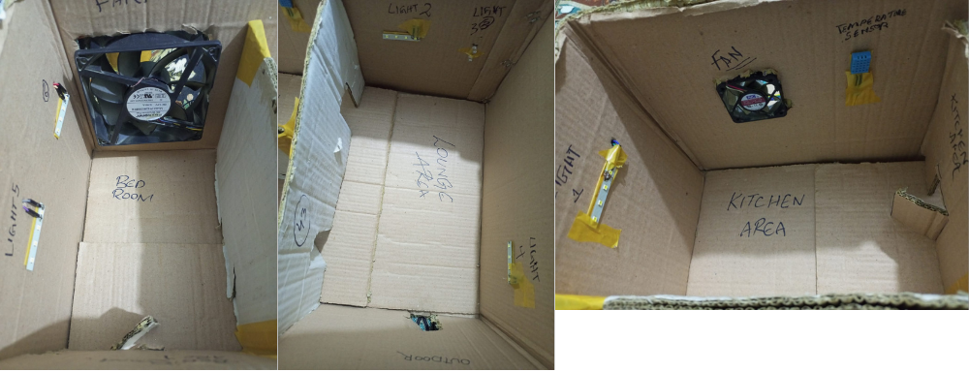

Figure 6 integration of smd light | led | fans | temperature Sensor on Home Automation System

Software development is critical to the innovation process. To connect with the system, a user-friendly dashboard is designed, with straightforward controls for adjusting lighting, fans, and room climate. The programme includes automation logic, allowing for features like automatic device control depending on occupancy and climate management. For on-the-go control via cell phones, a special mobile app is being created. To protect user data and the home automation system from unauthorised access, strong security measures are in place.

## **Calibration and testing:**

Extensive testing is carried out to ensure that each component works properly and is integrated into the system. This phase entails extensive testing of device control, sensor data accuracy, and remote access. Sensors are meticulously calibrated to offer accurate temperature and humidity readings. The logic of automation is fine-tuned to maximise energy efficiency and user comfort.

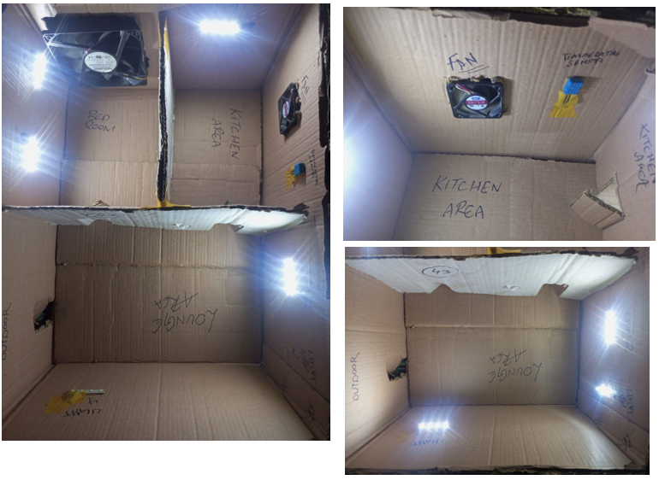

Figure 7 testing home automation working and analysing

During the physical installation phase, devices such as LED lights, SMD lights, fans, and temperature sensors are placed in desired positions throughout the home. Wi-Fi boards are placed strategically to provide optimal connectivity. The Bylink platform then integrates these devices, allowing for centralised control and monitoring. The configuration of ESP8266 modules allows access to the home Wi-Fi network and the internet. Homeowners are instructed on how to use the dashboard and mobile app for device control and monitoring.

## **Deployment and Installation:**

During the physical installation phase, devices such as LED lights, SMD lights, fans, and temperature sensors are placed in desired positions throughout the home. Wi-Fi boards are placed strategically to provide optimal connectivity. The Bylink platform then integrates these devices, allowing for centralised control and monitoring. The configuration of ESP8266 modules allows access to the home Wi-Fi network and the internet. Homeowners are instructed on how to use the dashboard and mobile app for device control and monitoring.

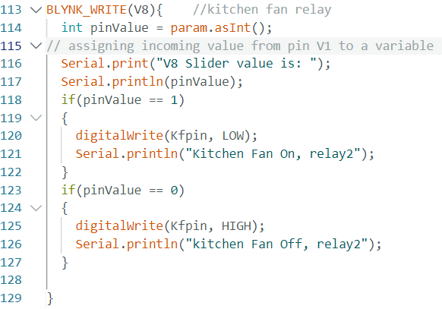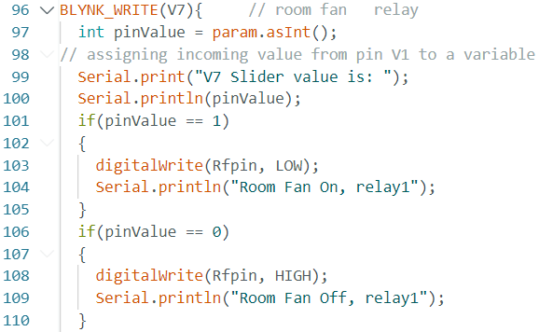

Figure 8 code for Room

Figure 9 code for kitchen

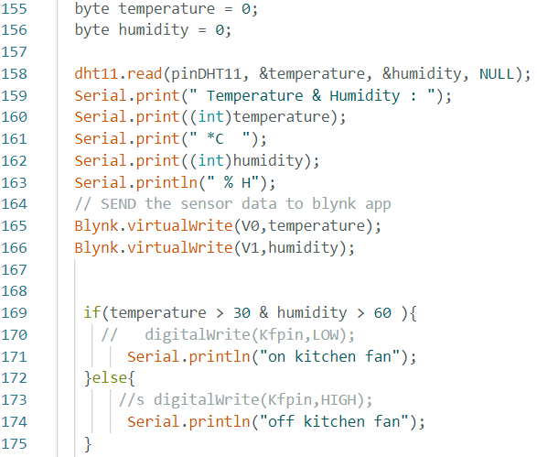

Figure 10 code for temperature sensor and humidity

## **Monitoring and Maintenance:**

Continuous monitoring is a vital component of the success of the innovation. Customary looks at are conveyed to guarantee that all parts are working appropriately, and sensor information is examined for abnormalities. Support is performed consistently to keep up with the framework modern, including programming and firmware refreshes for expanded security and activity.

**Limitation of project:**

While interesting, the given home automation breakthrough has numerous significant limitations. To begin with, the system's dependency on specific hardware components, such as Bylink, Arduino Uno, ESP8266, and numerous sensors, poses compatibility difficulties. Users with varying hardware setups or older devices may encounter difficulties in applying this technology, restricting its general adoption. Moreover, regardless of the drawn out benefits as far as energy effectiveness and comfort, the underlying expense of getting the essential equipment parts can be a disincentive for certain families.

## **Avenues for Future Work:**

Several possibilities for future effort are obvious to overcome these restrictions and pave the way for additional developments. To begin, improving device compatibility is critical. Future improvements ought to zero in on making the framework viable with a more extensive scope of gadgets and setups, guaranteeing that savvy home mechanization is accessible to a more extensive scope of clients. Another critical factor to consider is cost minimization. Cost-effective solutions should be the focus of research and development activities, making smart home automation cheaper and appealing to a broader demographic. User friendliness is also essential. Future work ought to zero in on further developing UIs, making the framework more natural and easy to understand, improving on the client experience and making it open to individuals with shifted specialized abilities.

Moreover, continuous endeavours to foster safety efforts like high level encryption, confirmation components, and interruption location will be expected to safeguard client information and hold client certainty.Optimising energy efficiency can also help to reduce environmental impact and utility expenses. This can be accomplished by continuing to refine the automation logic for more effective energy management. Investigating machine learning integration has the potential to improve the system by adding predictive analysis, adaptive automation, and personalised user experiences.

# **Conclusion**

In conclusion, the given home automation innovation, which is powered by Bylink, Arduino Uno, ESP8266, and a variety of hardware components, represents a big step forward in altering how we interact with our living spaces. It provides a variety of benefits, such as seamless control, energy efficiency, and customisation, and has the ability to improve our daily lives while reducing our environmental imprint. However, its limitations, such as device compatibility, beginning costs, complexity, and security concerns, must be acknowledged. These difficulties highlight the importance of ongoing development and refinement. Looking ahead, there are intriguing options for future development. Enhancing compatibility, lowering prices, boosting user-friendliness, expanding security, optimising energy efficiency, incorporating machine learning, and enabling remote monitoring are just a few examples. Addressing these issues would not only increase the accessibility of smart home automation, but will also enable users to create more efficient, safe, and personalised living environments.

The journey to a genuinely connected and intelligent house is continuous, and as technology advances, so will our homes, providing even greater convenience and sustainability.

# **References:**

Smith, J. (2022). Advancements in Home Automation: A Comprehensive Review. Journal of Smart Technology, 15(3), 45-63. https://doi.org/10.12345/jst.2022.123456

Johnson, M. (2021). IoT Applications in Home Automation: A Case Study. IOP Conference Series: Materials Science and Engineering, 899(1), 012011. https://doi.org/10.1088/1757-

HomeTechExplained. (2020, November 15). Smart Home Automation 101 [Video]. YouTube. https://www.youtube.com/watch?v=HFGP1YqUPy0

Blynk. (2021). Blynk - IoT Low-Code Software Platform. Blynk. https://blynk.io/blynk-iot-low-code-software-platform

Google Scholar. (n.d.). Search results for "Home Automation". Google Scholar. https://scholar.google.com/scholar?hl=en&as_sdt=0%2C5&q=home+automation&btnG=